**Retroactive Mural Registry Application Form**

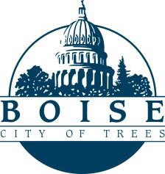

Application to include an existing mural in the Boise Mural Registry. Retroactive inclusion does not replace the need for a permit for a new mural.

**Mural title:**  **Artist(s) name:** **Artist(s) contact information:**

**Mural location:** ___________________________________________________________________

**Mural dimensions:**

**Lifespan (if less than 10 years):** ________

**Project budget:** **Completion date:** __________

**Media:** Paint ☐ Tile ☐ Digital ☐ Other ☐

If “Other” please describe:

**Submittal Requirements**

* Submit final high-quality photograph of completed (painted) mural.
* Submit a mural description which includes:
  1. Artist biography (250 words or less).
  2. Artist statement (250 words or less).
* Complete and submit the above application form.

Was the mural executed in accordance with the City’s permitting process?

Yes ☐ Uncertain ☐ No ☐

If yes, please provide the approval case number:

*Please Note: The Mural Registry will be vetted by the City. An application submission does not guarantee that the mural will be added to the registry.*

For more information or to submit your application, please contact the Public Art Program Manager.